.

**Department of Artificial Intelligence & Data Science**| **Rajalakshmi Engineering College**

96

[06 - List in Python](https://www.rajalakshmicolleges.net/moodle/course/view.php?id=84&section-5)

**Ex. No. : 6.1 Date: 04.05.24**

**Register No.: 231801097 Name: MANOJKUMAR M**

# Element Insertion

Consider a program to insert an element / item in the sorted array. Complete the logic by filling up required code in editable section. Consider an array of size 10. The eleventh item is the data is to be inserted.

Sample Test Cases Test Case 1

Input 1

3

4

5

6

7

8

9

10

11

2

Output

ITEM to be inserted:2 After insertion array is: 1

2

3

4

5

6

7

8

9

10

11

Test Case 2 Input

11

22

33

.

**Department of Artificial Intelligence & Data Science**| **Rajalakshmi Engineering College**

97

55

66

77

88

99

110

120

44

Output

ITEM to be inserted:44 After insertion array is: 11

22

33

44

55

66

77

88

99

110

120

**Program:**

x=[]

for i in range(0,11): b=int(input()) x.append(b)

#a.sort()

print("ITEM to be inserted:",x[-1],sep='') x.sort()

print("After insertion array is:") for i in x:

print(i)

.

**Department of Artificial Intelligence & Data Science**| **Rajalakshmi Engineering College**

98

.

**Department of Artificial Intelligence & Data Science**| **Rajalakshmi Engineering College**

99

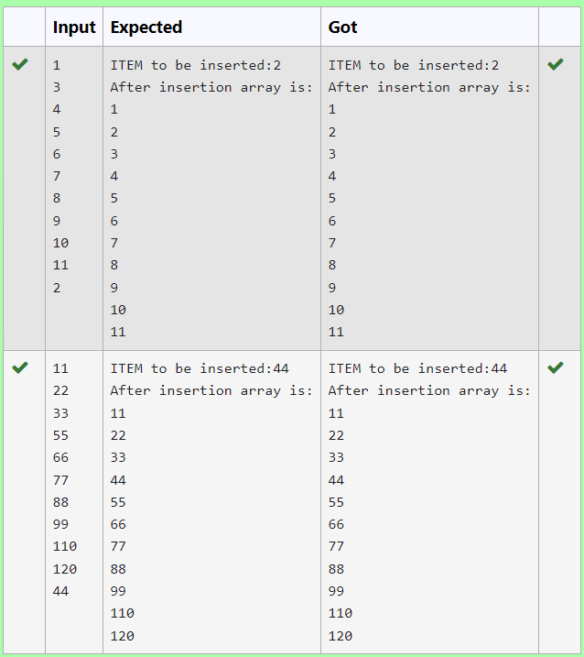

**Ex. No. : 6.2 Date: 04.05.24**

**Register No: 231801097 Name: MANOJKUMAR M**

**Anagram**

Given two lists A and B, and B is an anagram of A. B is an anagram of A means B is made by randomizing the order of the elements in A.

We want to find an *index mapping* P, from A to B. A mapping P[i] = j means the ith element in A appears in B at index j.

These lists A and B may contain duplicates. If there are multiple answers, output any of them.

For example, given

## Input

5

12 28 46 32 50

50 12 32 46 28

## Output

1 4 3 2 0

## Explanation

A = [12, 28, 46, 32, 50]

B = [50, 12, 32, 46, 28]

We should return [1, 4, 3, 2, 0]

as P[0] = 1 because the 0th element of A appears at B[1], and P[1] = 4 because the 1st element of A appears at B[4], and so on.

## Note:

1. A, B have equal lengths in range [1, 100].
2. A[i], B[i] are integers in range [0, 10^5].

.

**Department of Artificial Intelligence & Data Science**| **Rajalakshmi Engineering College**

100

.

**Department of Artificial Intelligence & Data Science**| **Rajalakshmi Engineering College**

101

## Program:

.

**Department of Artificial Intelligence & Data Science**| **Rajalakshmi Engineering College**

102

def index_mapping(A, B):

index_map = {num: i for i, num in enumerate(B)} return ' '.join(str(index_map[num]) for num in A)

n=int(input())

A = list(map(int, input().split()))

B = list(map(int, input().split())) print(index_mapping(A, B))

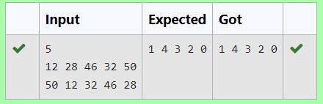

**Ex. No. : 6.3 Date: 04.05.24**

.

**Department of Artificial Intelligence & Data Science**| **Rajalakshmi Engineering College**

103

**Register No : 231801097 Name: MANOJKUMAR M**

# Merge Two Sorted Arrays Without Duplication

Output is a merged array without duplicates. Input Format

N1 - no of elements in array 1 Array elements for array 1 N2 - no of elements in array 2 Array elements for array2 Output Format

Display the merged array

## Sample Input 1

5

1

2

3

6

9

4

2

4

5

10

## Sample Output 1

1 2 3 4 5 6 9 10

**Program:** n1=int(input()) l1=[]

for i in range(0,n1): a=int(input()) l1.append(a)

n2=int(input()) l2=[]

for i in range(0,n2): a=int(input()) l2.append(a)

l3=[]

l3.extend(l1) l3.extend(l2) a=list(set(l3)) a.sort()

for i in a:

print(i,end=' ') n1=int(input()) l1=[]

for i in range(0,n1): a=int(input()) l1.append(a)

n2=int(input()) l2=[]

for i in range(0,n2): a=int(input()) l2.append(a)

l3=[]

l3.extend(l1) l3.extend(l2) a=list(set(l3)) a.sort()

for i in a: print(i,end=' ')

.

**Department of Artificial Intelligence & Data Science**| **Rajalakshmi Engineering College**

104

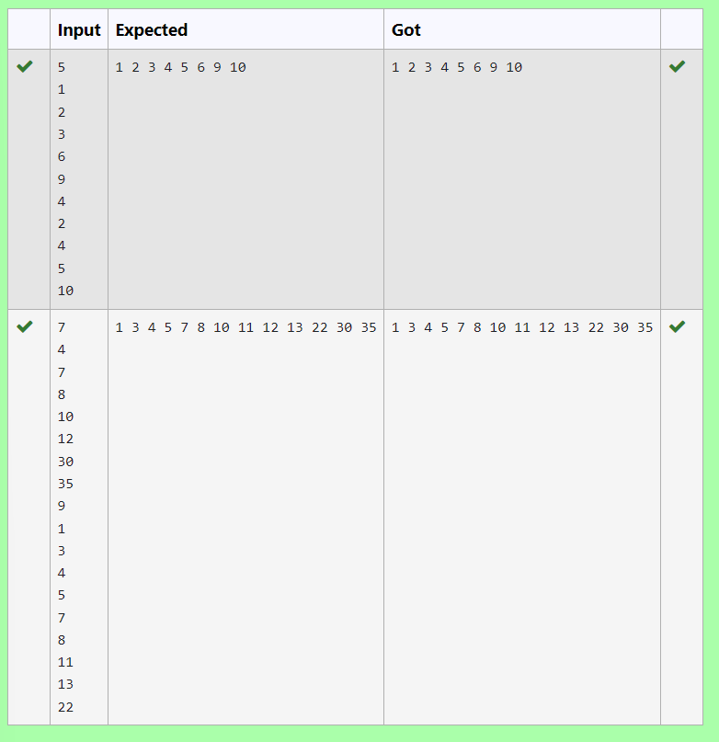

.

**Department of Artificial Intelligence & Data Science**| **Rajalakshmi Engineering College**

105

**Ex. No. : 6.4 Date: 04.05.24**

.

**Department of Artificial Intelligence & Data Science**| **Rajalakshmi Engineering College**

106

**Register No : 231801097 Name: MANOJKUMAR M**

# Distinct Elements in an Array

Program to print all the distinct elements in an array. Distinct elements are nothing but the unique (non-duplicate) elements present in the given array.

Input Format:

First line take an Integer input from stdin which is array length n. Second line take n Integers which is inputs of array.

Output Format:

Print the Distinct Elements in Array in single line which is space Separated

Example Input: 5

1

2

2

3

4

Output:

1 2 3 4

Example Input: 6

1

1

2

2

3

3

Output: 1 2 3

.

**Department of Artificial Intelligence & Data Science**| **Rajalakshmi Engineering College**

107

## For example:

|  |  |
| --- | --- |
| **Input** | **Result** |
| 5  1  2  2  3  4 | 1 2 3 4 |
| 6  1  1  2  2  3  3 | 1 2 3 |

**Program:**

n = int(input()) arr = []

for _ in range(n): arr.append(int(input()))

distinct_elements = set(arr) print(*distinct_elements)

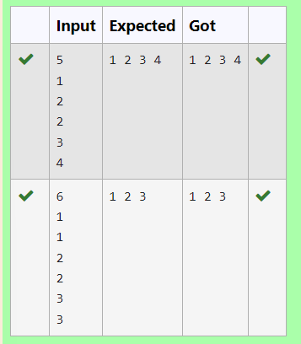

.

**Department of Artificial Intelligence & Data Science**| **Rajalakshmi Engineering College**

108

**Ex. No. : 6.5 Date: 04.05.24**

**Register No : 231801097 Name: MANOJKUMAR M**

# The Pivot

Given an array of numbers, find the index of the smallest array element (the pivot), for which the sums of all elements to the left and to the right are equal. The array may not be reordered.

Example arr=[1,2,3,4,6]

* the sum of the first three elements, 1+2+3=6. The value of the last element is 6.
* Using zero based indexing, arr[3]=4 is the pivot between the two subarrays.
* The index of the pivot is 3. Constraints

· 3 ≤ n ≤ 105

· 1 ≤ arr[i] ≤ 2 × 104, where 0 ≤ i < n

* It is guaranteed that a solution always exists.

The first line contains an integer n, the size of the array arr.

Each of the next n lines contains an integer, arr[i], where 0 ≤ i < n. Sample Case 0

Sample Input 0

4

1

2

3

3

Sample Output 0

2

Explanation 0

* The sum of the first two elements, 1+2=3. The value of the last element is 3.

.

**Department of Artificial Intelligence & Data Science**| **Rajalakshmi Engineering College**

109

* Using zero based indexing, arr[2]=3 is the pivot between the two subarrays.

.

**Department of Artificial Intelligence & Data Science**| **Rajalakshmi Engineering College**

110

* The index of the pivot is 2.

Sample Case 1

Sample Input 1

3

1

2

1

Sample Output 1

1

Explanation 1

* The first and last elements are equal to 1.
* Using zero based indexing, arr[1]=2 is the pivot between the two subarrays.
* The index of the pivot is 1.

**For example:**

|  |  |
| --- | --- |
| **Input** | **Result** |
| 4  1  2  3  3 | 2 |
| 3  1  2  1 | 1 |

## Program:

.

**Department of Artificial Intelligence & Data Science**| **Rajalakshmi Engineering College**

111

a = int(input()) b= []

for i in range(a): element = int(input()) b.append(element)

total= sum(b) left= 0

right = total- b[0] if left== right:

print(0) exit()

for i in range(1, a): left+= b[i - 1] right-= b[i]

if left== right: print(i) break

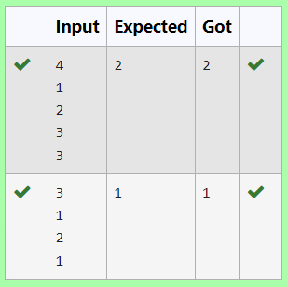

**Ex. No. : 6.6 Date: 04.05.24**

**Register No : 231801097 Name: MANOJKUMAR M**

# Intersection of array

Find the intersection of two sorted arrays. OR in other words,

Given 2 sorted arrays, find all the elements which occur in both the arrays. Input Format

The first line contains T, the number of test cases. Following T lines contain:

1. Line 1 contains N1, followed by N1 integers of the first array
2. Line 2 contains N2, followed by N2 integers of the second array Output Format

The intersection of the arrays in a single line Example

Input:

1

3 10 17 57

6 2 7 10 15 57 246

Output: 10 57

Input: 1

7

1

2

3

3

4

5

.

**Department of Artificial Intelligence & Data Science**| **Rajalakshmi Engineering College**

112

6

.

**Department of Artificial Intelligence & Data Science**| **Rajalakshmi Engineering College**

113

2

1

6

Output:

1 6

## For example:

|  |  |
| --- | --- |
| **Input** | **Result** |
| 1  3  10  17  57  6  2  7  10  15  57  246 | 10 57 |
| 1  7  1  2  3  3  4  5  6  2  1  6 | 1 6 |

.

**Department of Artificial Intelligence & Data Science**| **Rajalakshmi Engineering College**

114

**Program:** t=int(input()) l1=list() while(t!=0):

n1=int(input()) l1=[]

l2=[]

for i in range(0,n1): a=int(input()) l1.append(a)

n2=int(input())

for i in range(0,n2): a=int(input()) l2.append(a)

t=t-1 c=set(l1) d=set(l2)

e=list(c.intersection(d)) e.sort()

for i in e: print(i,end=' ')

print('\n')

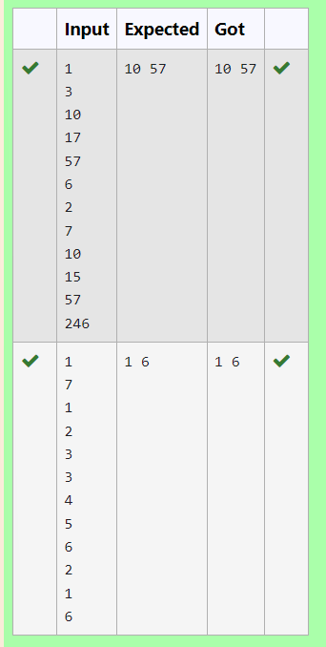

.

**Department of Artificial Intelligence & Data Science**| **Rajalakshmi Engineering College**

115

**Ex. No. : 6.7 Date: 04.05.24**

**Register No.:231801097 Name: MANOJKUMAR M**

# Location

Write a program to print all the locations at which a particular element (taken as input) is found in a list and also print the total number of times it occurs in the list. The location starts from 1.

For example, if there are 4 elements in the array: 5

6

5

7

If the element to search is 5 then the output will be: 5 is present at location 1

5 is present at location 3

5 is present 2 times in the array. Sample Test Cases

Test Case 1 Input

4

5

6

5

7

5

Output

5 is present at location 1.

5 is present at location 3.

5 is present 2 times in the array.

.

**Department of Artificial Intelligence & Data Science**| **Rajalakshmi Engineering College**

116

Test Case 2 Input

5

67

80

45

97

100

50

Output

50 is not present in the array.

**Program:**

n = int(input())

arr = [int(input()) for _ in range(n)] element_to_search = int(input()) locations = []

occurrences = 0

for i in range(len(arr)):

if arr[i] == element_to_search: locations.append(i + 1)

occurrences +=1 if occurrences == 0:

print(f"{element_to_search} is not present in the array.") else:

for loc in locations:

print(f"{element_to_search} is present at location {loc}.") print(f"{element_to_search} is present {occurrences} times in the array.")

.

**Department of Artificial Intelligence & Data Science**| **Rajalakshmi Engineering College**

117

.

**Department of Artificial Intelligence & Data Science**| **Rajalakshmi Engineering College**

118

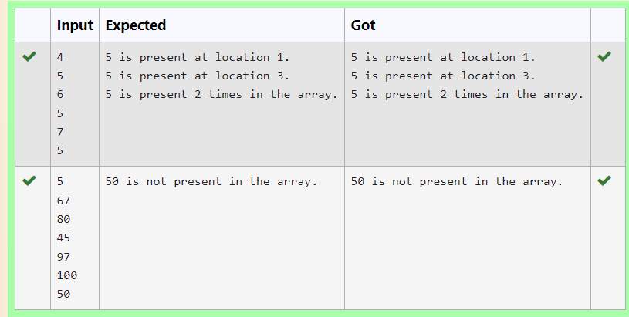

**Ex. No. : 6.8 Date: 04.05.24**

**Register No : 231801097 Name: MANOJKUMAR M**

# Strictly increasing

Write a Python program to check if a given list is strictly increasing or not. Moreover, If removing only one element from the list results in a strictly increasing list, we still consider the list true

Input:

n : Number of elements List1: List of values Output

Print "True" if list is strictly increasing or decreasing else print "False" Sample Test Case

Input 7

1

2

3

0

4

5

6

Output True

.

**Department of Artificial Intelligence & Data Science**| **Rajalakshmi Engineering College**

119

**Program:**

def check_increasing_or_decreasing(lst): increasing = True

decreasing = True

for i in range(1, len(lst)): if lst[i] > lst[i - 1]:

decreasing = False elif lst[i] < lst[i - 1]:

increasing = False

return increasing or decreasing

def check_strictly_increasing_with_removal(lst): for i in range(len(lst)):

temp_lst = lst[:i] + lst[i+1:]

if check_increasing_or_decreasing(temp_lst): return True

return False n = int(input()) lst = []

for _ in range(n): lst.append(int(input())

if check_increasing_or_decreasing(lst) or check_strictly_increasing_with_removal(lst):

.

**Department of Artificial Intelligence & Data Science**| **Rajalakshmi Engineering College**

120

print("True") else:

.

**Department of Artificial Intelligence & Data Science**| **Rajalakshmi Engineering College**

121

print("False")

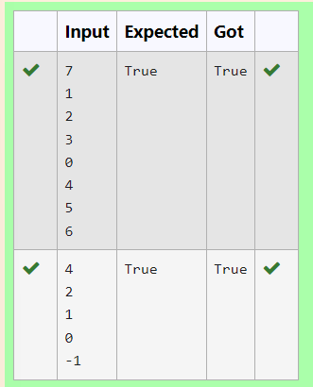

**Ex. No. : 6.9 Date: 04.05.24**

.

**Department of Artificial Intelligence & Data Science**| **Rajalakshmi Engineering College**

122

**Register No : 231801097 Name: MANOJKUMAR M**

# Merge List

Write a Python program to Zip two given lists of lists.

Input:

m : row size n: column size

list1 and list 2 : Two lists Output

Zipped List : List which combined both list1 and list2 Sample test case

Sample input 2

2

1

3

5

7

2

4

6

8

Sample Output

[[1, 3, 2, 4], [5, 7, 6, 8]]

**Program:** m=int(input()) n=int(input()) l1=[]

.

**Department of Artificial Intelligence & Data Science**| **Rajalakshmi Engineering College**

123

l2=[]

c=1

for i in range(0,m*n*2,2): a=int(input()) b=int(input())

if c%2!=0: l1.append(a) l1.append(b)

else:

l2.append(a) l2.append(b)

c=c+1 l3=[]

l3.append(l1) l3.append(l2) print(l3)

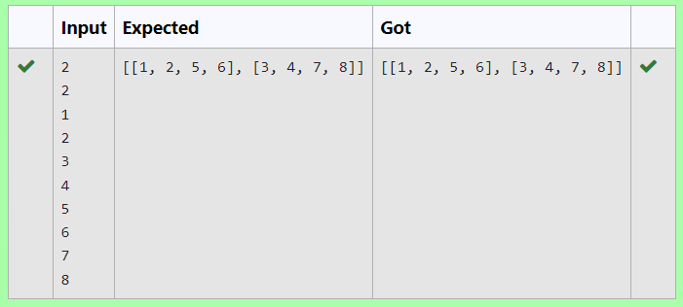

.

**Department of Artificial Intelligence & Data Science**| **Rajalakshmi Engineering College**

124

**Ex. No. : 6.10 Date: 04.05.24**

.

**Department of Artificial Intelligence & Data Science**| **Rajalakshmi Engineering College**

125

**Register No : 231801097 Name : MANOJKUMAR M**

# Check pair with difference k

Given an array A of sorted integers and another non negative integer k, find if there exists 2 indices i and j such that A[i] - A[j] = k, i != j.

Input Format

1. First line is number of test cases T. Following T lines contain:
2. N, followed by N integers of the array
3. The non-negative integer k Output format

Print 1 if such a pair exists and 0 if it doesn’t.

Input 1

3

1

3

5

4

Output:

1

Input 1

3

1

3

5

99

Output 0

**For example:**

|  |  |
| --- | --- |
| **Input** | **Result** |
| 1  3  1  3  5 | 1 |

|  |  |
| --- | --- |
| **Input** | **Result** |
| 4 |  |
| 1 | 0 |
| 3 |  |
| 1 |  |
| 3 |  |
| 5 |  |
| 99 |  |

## Program:

t=int(input())

for i in range(0,t): n=int(input()) l=[]

for j in range(0,n): a=int(input()) l.append(a)

p=int(input())

for k in range(0,n): c=0

for m in range(i+1,n): if l[m]-l[k]==p:

c=1 print('1') break

if c==1:

.

**Department of Artificial Intelligence & Data Science**| **Rajalakshmi Engineering College**

126

break if c==0:

.

**Department of Artificial Intelligence & Data Science**| **Rajalakshmi Engineering College**

127

print('0')

